User’s Manual

~PROSYNC-9370~

Industrial Single Board
Pentium III CPU Card with LCD, Ethernet, SCSI

Location of Connectors and Jumpers

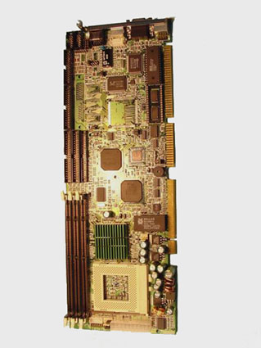
P1, P2
J11, JP3
JP7
JP4
J16, J17
JP14
W4
FAN
POWER
P3
Pane1
JP6
IDE0.1
FDC
Print
IrDA
USB
LAN
Mouse
VGA
Keyboard
DOC
DIMMs
CPU
COM1, 2

Setting jumpers
You can configure system to match the needs of your application by setting jumpers. A jumper is the simplest kind of electric switch. It consists of two metal pins and a small metal clip (often protected by a plastic cover) that slides over the pins to connect them. To jumper you remove the clip. Sometimes a jumper will have three pins, labeled 1, 2, and 3. In this case you would connect either pins 1 and 2 or 2 and 3.

The jumper settings are schematically depicted in this manual as follows:
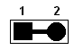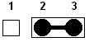 off on on 2-3
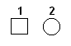

On board standby power select
Before power on the system, have to check the power resource and choice the right “standby power select jumper”. The jumper must put on the right position otherwise system will not work.
If the power comes from back-end only, the JP6 (on bard standby
power select) select “3-4 on”.
If the power direct connect to PROSYNC-9370 “POWER” connect, the JP6
(on board standby power) select “3-4 off”.

Normal Power Direct Connect
to CPU Card
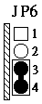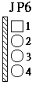
Clear CMOS (option I for Dallas 12887A only)
When Dallas 12887A on board, you can use W4 to clear the CMOS data if necessary. To reset the CMOS data, set W4 to 1-2 closed for just a few seconds, and then move off the jumper.
Clear CMOS (W4)
Normal Clear CMOS
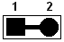W4
*default

Clear CMOS (option II for Lithium Battery only)
You can use JP11 to clear the CMOS when the system with Lithium Battery not Dallas 12887A. To reset the CMOS data, set JP11 to 2-3 for just a few seconds, and then move the jumper back to 1-2.

Clear CMOS (JP11)
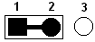 Normal Clear CMOS
JP11 * default
COM2 RS232/422/485 Select
The PROSYNC-9370 COM2 serial port can be select as RS-232 or RS-422/485
by setting P1, P2, J11 and JP3.

COM2 RS-232/422/485
P1 & P2 J11 & JP3
RS-232
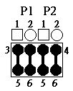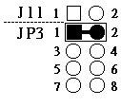
*Default
RS-422
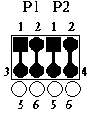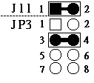
*Option only
RS-485
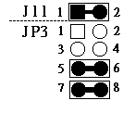 *Option only

LCD driving voltages select (JP4)
You can select the LCD connector “PANEL” driving voltage by setting JP4. The configurations are as follows:
LCD driving voltages select (JP4)
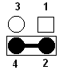 5V 3.3V
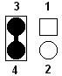JP4
* default
Please contact your LCD panel supplier for makes sure a correct LCD’s working voltage.
** Any mistake will cause defect your LCD panel

DOC addresses select (J16, J17)
The DiskOnChip 2000 occupies an 8 Kbytes window in the upper memory address range of D4000 to DC000. You should ensure this does not conflict with any other device’s memory address. J16, J17 selects the memory address window of the Flash disk.

DiskOnChip 2000 memory address J16, J17
Memory Address (HEX)
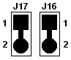D4000
*default
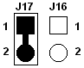D8000

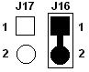DC000
Disable
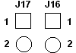
These addresses might conflict with the ROM BIOS of other peripheral boards. Please select the appropriate memory address to avoid memory conflicts.

Watch Dog Counter Select (JP14)
The watch dog counter can be selected for IRQ11, NMI or
system RESET by setting the JP14.

Watch Dog Counter Select (JP14)
IRQ11 NMI Reset
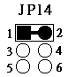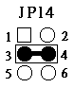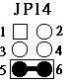
* default

Ethernet Select (JP7)
The RTL8139 Ethernet can be enable or disable by setting the JP7

Ethernet select (JP7)
Disable Normal
P7
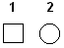 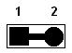 *default

Front side multi-function connector (P3)
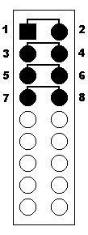The pin 1 and pin 2 of P3 is used for “power on” switch. You can short these two pins to turn on the power when the power direct connects to PROSYNC-9370 “POWER” connector.
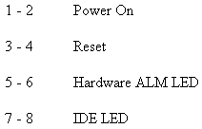The pin 3 and pin 4 of P3 is used for reset system. You can short these two pins to reset the system.
The pin7 and pin8 of P3 is used for hard disk drive active LED. You can connect LED to these two pins to indicate HDD active.

The pin 9 and pin 15 of P3 is used for speaker connector function. You can connect these two pins to the external speaker. Normal the pin 15 and pin 17 be short for internal buzzer.
The pin10 and pin 12 of P3 is used for key-lock function. You can use a switch (or a lock) to disable the keyboard so the PC will not respond to any keyboard input. This is useful if you do not want anyone to change or stop a running program.
The pin 14 and pin 18 (or pin 16) is used for “system on” function.
You can use an LED to indicate when the CPU card is on. Pin 18, pin16 are supplying the LED’s power, and Pin14 is the ground.
